Project Report: Theoretical Background and Methodology
1. Introduction
The primary objective of this project is to develop a robust system for Underwater Voice Separation capable of detecting and counting the number of marine vessels in a noisy environment. The solution is architected in a multi-stage pipeline beginning with spatial filtering to isolate directional signals, followed by spectral estimation for signal visualization, and concluding with advanced Machine Learning (ML) and Deep Learning algorithms for the final separation and counting tasks. This hybrid approach leverages classical signal processing to clean and format the data, while relying on data-driven models to perform the complex classification of distinct acoustic signatures.
2. Stage 1: Spatial Filtering (Beamforming)
Theoretical Background and Methodology
In a multi-source underwater environment, a single hydrophone receives a superposition of all acoustic sources, including targets, interferences, and ambient noise. To separate these distinct voices, we employ a Phased Array approach using a Uniform Linear Array (ULA). Beamforming is the fundamental signal processing technique used here for directional signal reception. By combining elements in a phased array, signals arriving from particular angles experience constructive interference while signals from other directions experience destructive interference. For a linear array of $N$ sensors with spacing $d$, the beamformer applies a delay-and-sum operation. To steer the array's listening direction to an angle $θ_{0}$, a phase shift $ψ$ is applied to the signal of each n-th element. This phase shift is calculated as:
$$(1) ψ_{n} = -n⋅\frac{2π}{λ}dsin(θ_{0})$$
where $λ$ is the wavelength of the signal. In the context of this project, Beamforming serves as the critical spatial filter. The motivation for this step is that before we can count the number of vessels or identify their frequencies, we must spatially separate them. Without this initial spatial filtering, a strong jammer or interference source from one direction would mask a weaker target from another direction in the frequency domain. To implement this, we utilize a Direction of Arrival (DOA) scanning algorithm that steers the beam $θ$ from -90° to +90°. This scanning mechanism effectively allows the system to look in one direction at a time, suppressing noise from all other sectors and creating a spatially filtered time-series signal that is ready for subsequent processing.
3. Stage 2: Spectral Estimation
Theoretical Background and Method Selection
Once the beamformer has isolated a signal from a specific angle, the next challenge is to estimate its Power Spectral Density (PSD) to determine if a vessel exists at that angle and to identify its characteristic frequency. We evaluated four statistical methods based on the trade-off between variance and resolution as analyzed in the project's preliminary study. The first method considered was the Periodogram, which is the standard estimator based on the squared magnitude of the Discrete Fourier Transform (DFT), defined as:
$$(2) {\hat{P}}_{per}\left(f\right)=\frac{1}{N}{\left|X\left(f\right)\right|}^{2}$$
To address the limitations of the Periodogram, we evaluated Bartlett’s Method, which reduces variance by splitting the signal into K non-overlapping segments and averaging their periodograms:
$$(3) {\hat{P}}_{Bart}\left(f\right)=\frac{1}{K}\sum_{i=1}^{K}{{\hat{P}}_{i}\left(f\right)}$$
While this reduces the noise variance by a factor of K, it unfortunately reduces the frequency resolution by the same factor, which poses a risk of missing two closely spaced vessel frequencies. We then analyzed Welch’s Method, which improves upon Bartlett by allowing segments to overlap, typically by 50%, and applying a window function such as a Hamming window. This method provides a significant reduction in noise variance while maintaining better data utilization than Bartlett due to the overlap, making it an industry standard for robust detection. Finally, we considered the Blackman-Tukey Method, which computes the PSD by taking the FFT of the windowed biased autocorrelation sequence $R_{xx}$, utilizing a lag window w[m]:
$$(4) {\hat{P}}_{BT}\left(f\right)=FFT\{w\left[m\right]⋅{\hat{R}}_{xx}[m]\}$$
By applying a window of length M to the lag domain, high-frequency noise in the spectrum is effectively smoothed out.
For the final Voice Separation system, we selected Welch's Method and the Blackman-Tukey Method over the standard Periodogram. The justification for this selection is threefold. First, regarding noise rejection, our simulation results demonstrated that the raw Periodogram failed to provide a clear peak for the target in high-noise conditions, whereas Welch’s method successfully averaged out the Gaussian noise to reveal the target at 1200 Hz. Second, concerning visualization, the Blackman-Tukey method provided the smoothest spectral curve, which is critical when automating the counting of vessels to prevent the algorithm from interpreting random noise peaks as distinct vessels or false positives. Third, regarding consistency, Welch's method offers the lowest Mean Squared Error (MSE) for signals with complex noise characteristics, making it the most reliable choice for our detection logic.
4. Simulation Results: Spatial Filtering (Stage 1)
To demonstrate the efficacy of the spatial filtering stage, we generated the Beam Pattern (Array Factor) for our Uniform Linear Array when steered towards the target vessel at 30°. The figure below illustrates the spatial gain of the array across all angles.
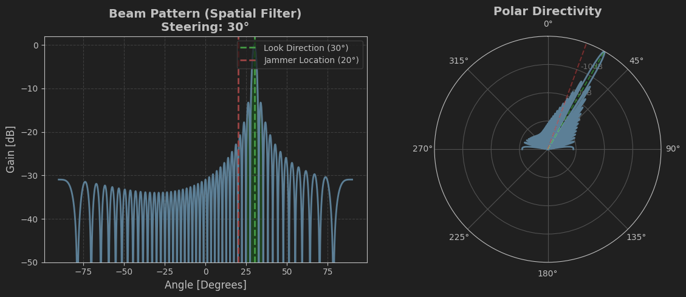
The visualization confirms the system's spatial selectivity. The "Main Lobe" (the peak of the graph) is precisely aligned with the target angle of 30°, providing maximum gain (0 dB) for signals arriving from this direction. Crucially, the Side Lobes represent directions of attenuated sensitivity. The red dashed line marks the location of the strong interference source (jammer) at 20°. As seen in the plot, the array geometry ensures that the gain at the jammer's angle is significantly lower than the main lobe (attenuated by approximately 20-25 dB). This spatial filtering capability effectively suppresses the interference before the signal reaches the spectral estimation stage, ensuring that the subsequent frequency analysis focuses primarily on the target vessel.
4. Simulation Results and Discussion
To validate the theoretical approach described above, a comprehensive simulation was conducted in a high-noise environment. The simulation scenario included a weak target vessel emitting a signal at 1200 Hz located at 30 degrees, a strong interference source (jammer) at 3500 Hz located at 20 degrees, and significant white Gaussian noise. The figure below presents the comparative results of the four spectral estimation methods applied to the beamformed signal.
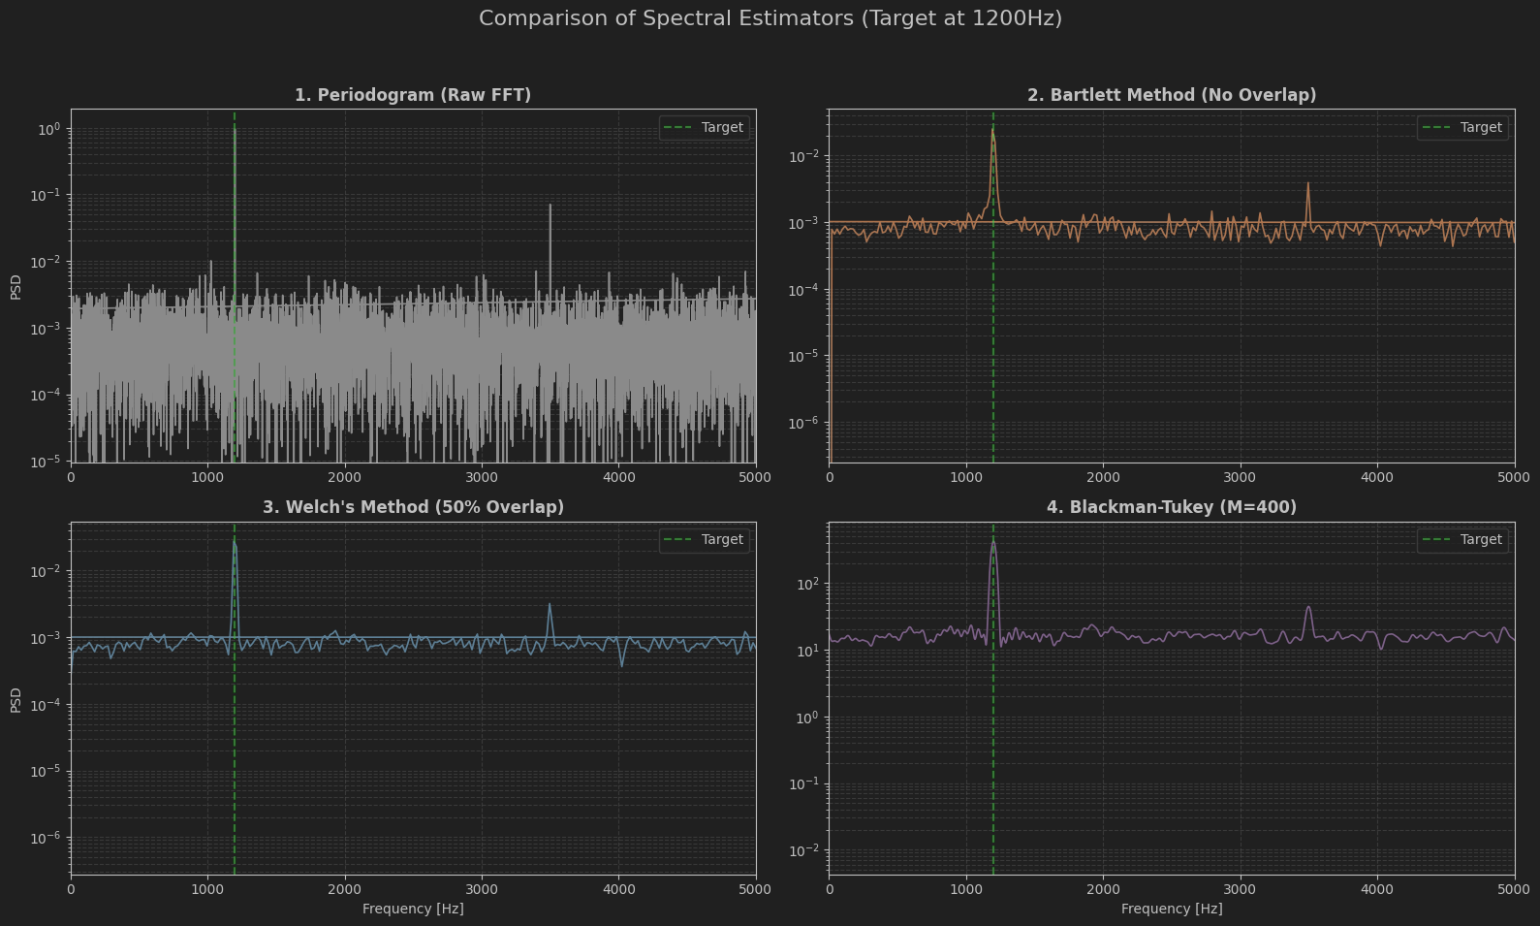
The first panel illustrates the Periodogram, which exhibits high variance and a jagged noise floor, making it difficult to distinguish the 1200 Hz target from random noise spikes. The second panel displays Bartlett's method, where the variance is visibly reduced due to the averaging of non-overlapping segments, though some noise fluctuations remain. The third panel demonstrates the performance of Welch’s method, which shows a significant improvement in signal-to-noise ratio and a clearer definition of the target peak at 1200 Hz, confirming its reliability for detection. Finally, the fourth panel shows the Blackman-Tukey method, which produces the smoothest spectral estimate by windowing the autocorrelation function. This smoothness effectively suppresses the random noise variance, leaving a distinct and unambiguous peak at the target frequency. These results confirm that while the Periodogram is insufficient for this application, both Welch’s method and Blackman-Tukey provide the necessary stability and precision required for the automated counting and separation of vessel voices.
5. Conclusion
By combining these stages, our project achieves a robust framework for vessel separation. The Spatial Domain is handled by the Beamformer, which separates vessels based on their angle $θ$. The frequency content is processed and visualized using advanced spectral estimators like Welch or Blackman-Tukey to ensure data integrity. Finally, the core task of separation and counting is executed by Machine Learning and Deep Learning algorithms, which utilize the spatially filtered and spectrally processed data to accurately identify the number of vessels even in complex, high-interference environments.

